I. Social Problems

A. Study of social problems

1. What are social problems?

2. What are the causes?

3. What are the solutions?

B. Problem with identifying social problems?

1. Corporations, wealthy.

a. “big” government

i. over-regulation

ii. public ownership

iii. taxation

b. solutions

i. deregulation

ii. lower taxes

iii. privatization

iv. tort reform

v. subsidies; “bailouts”

vi. expand rights as persons

“free” speech”

participation in political process

2. Mass Media and Social Problems

a. violent crime

b. disease: SARS, West Nile Virus, “the Flu,”

Swine flu

c. how real are media social problems?

i. violent crime

ii. disease

d. Annenberg study

e. Media and the economic crisis

i. “Recovery”: GNP^, Corp profits^, Dow Jones^

ii. “Wow! I lost my job and my home and my family is on the street but Citigroup made $12 billion.”

iii. Story: 150,000 jobs lost ; Background visuals:

applause at the close of the stock market.

C. Starting Point for identifying social problems: US (or vital needs)

1. Vital needs to enjoy a decent life

a. Good job

i. decent wages

ii. reasonable hours

iii. security in job

iv. benefits

v. vacation/leisure time

b. housing

i. affordable

ii. quality

c. food security

d. accessible, affordable and quality education

e. environment

i. clean air

ii. clean water

f. accessible, affordable and quality health care

g. security of person and family

h. physical infrastructure

i. A voice in political system

2. Social problem from this perspective: when millions do not have their vital needs met

3. Vital needs as social problems

1. Jobs

i. types of jobs

ii. unemployment

are available; it’s that employers do not have enough work to be done to need to hire more workers.

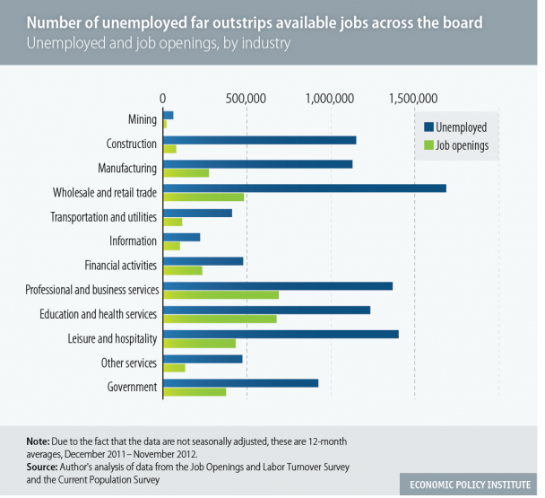

iii. real income

stagnant or declining

except top 1% (since 1976 56%)

iv. middle class jobs: increased hours

v. decline in benefits

30% companies cut or increased cost

stipend vs health care?

vi. decline in leisure time

b. Housing

i. by 2012 1 out 10 families forced out of homes

(2010 2.9 2011 2.6 2012 2.3 million)

ii. affordability

iii. homelessness

2 to 3.5 million per year

35% families, 13% veterans

c. food security

i. food insecurity

1 in 6 families food insecure

49 million/17 million children

4.8 million households used private food pantries

ii. since 2008: +17% Medicaid, +50% food stamps

iii. food safety: 200,000 per day

d. education

i. cost^ student debt ^

ii. K-12: closing schools

iii. quality

iv. safety (1/3, $200 billion)

e. environment

i. air quality

ii. chemical pollution

f. health and health care

i. poor health

ii. health care system: pre-“reform”

51 million

costs =+14% (130%), $12,000 a year f/4 (+87%)

exclusion

bankruptcies

iii. health care “reform”

“wealthfare”

stock value + 14 to 30%

who wrote it?

Where implemented first?

g security of person

1. criminal justice-industrial complex

2.3 million

25% of world’s incarceration population

ii. military-industrial-intelligence complex

761 bases in other countries

$1 trillion

NSA

h. physical infrastructure

i. sewage systems

ii. bridges

iii. roads

iv. electrical grids

v. railway

vi. informational networks

j. voice in political system

i. who runs?

ii. who finances?

II. Solving Social Problems

A. Understanding power: Who Rules America?

B. Power in American

1. upper class + large multinational corporations

2. plutocracy (plutonomy) or corporatism

Citigroup’s Equity Strategy

“Revisiting Plutonomy: The Rich Get Richer”

“These economies (U.S, UK, Canada and Australia) have seen the rich take an increasing share of income and wealth over the last 20 years, to the extent that the rich now dominate income, wealth and spending in these countries . . . favorable treatment by market friendly governments have allowed the rich to prosper and become a greater share of the economy in the plutonomy countries . . .[much of this increase] at the expense of labor.”

Warren Buffet, multibillionaire:

“There is a class war in America and my class is winning.”

C. Goals of those in power

1. rich (increase wealth) + corporations (increase profit and return on investment for shareholders)

2. maintain and further power

3. Success: increasing inequality

1. wealth

top 1%

trend. Since 1970: +2x

historically

comparatively

2001 to 2008 ($186 billion to $816 billion)

1. income

median

Geni index .466+

During “economic recovery” 2009-2010 top 1% 93% of all income growth

Types of income

1. corporations

<http://www.youtube.com/watch?v=Pin8fbdGV9Y&list=PLB3A3B6087444D958>

<http://www.youtube.com/watch?v=8SuUzmqBewg&list=PLB3A3B6087444D958>

size

concentration

profit

<http://www.thedailyshow.com/watch/mon-june-7-2004/tape-worms>

E. How do they rule?

1. make system of power invisible through the organization of its institutionalization

a. economic system

b. political system

c. education

d. health care

e. criminal justice

2. control ideas, beliefs, norms, conventional wisdoms through mass media and education

F. We are going to examine the structure of the following institutions.

1. Economy

2. Political system

1. Education
2. Health and Health Care

5. Mass media

Costco since 1990

Sales +13%

Profits +15% ($537 million)

Stock price +200%

Avg wage $20.00 (85% w/ benefits) $40,000

Wal-Mart since 1990

Sales +4/5%

Profits 7%

Stock price +70%

Avg wage $13.00 ? Sam’s Club $17,486